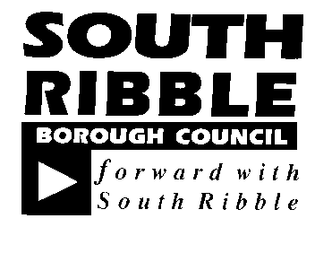  REPORT TO | ON
CABINET | 13 November 2019
TITLE | PORTFOLIO | REPORT OF
Preston and South Ribble Flood Defence Scheme | Cabinet Member for Environment | Director of Neighbourhoods and Development

Is this report a KEY DECISION (i.e. more than £100,000 or impacting on more than 2 Borough wards?)  Is this report on the Statutory Cabinet Forward Plan?  Is the request outside the policy and budgetary framework and therefore subject to confirmation at full Council?  Is this report confidential? | Yes  Yes  No  No

PURPOSE OF THE REPORT

- To provide information to Cabinet on the Preston and South Ribble Flood Management Scheme.

PORTFOLIO RECOMMENDATIONS

- Cabinet are asked to note the Preston and South Ribble Flood Management Scheme proposals and to provide on-going support, feedback and suggestions that can help shape/inform the ongoing process.

- Cabinet agrees to work with the Environment Agency to deliver improvements as part of the Green Links programme along the River Ribble and Darwen which will include a range of works to pathways, woodlands and open spaces.

REASONS FOR THE DECISION

- The Council is focused on ensuring South Ribble remains a great place to live and work by protecting green and open spaces and safeguarding our environment. The protection of our residents and businesses against flooding is essential especially for residents living near the River Ribble and River Darwen. The Council want our residents to feel that where they live is a place where they can be happy, healthy and safe.

CORPORATE OUTCOMES

- The report relates to the following corporate outcomes::

Excellence, Investment and Financial Sustainability

Health, Wellbeing and Safety | x
Place, Homes and Environment | x

Projects relating to People in the Corporate Plan:

Our People and Communities | x

BACKGROUND TO THE REPORT

- The Environment Agency (EA), Lancashire County Council, South Ribble Borough Council, Preston City Council and partners are working together to develop the Preston and South Ribble flood risk management scheme. This scheme will provide flood risk mitigation for communities from Penwortham up towards the M6 and Higher Walton.

- There is a long history of flooding in Preston and South Ribble and a large area which remains at risk of flooding from either the sea, River Ribble and Darwen or a combination of both. There are records of flooding to these communities in 1966, 1977, 1997, 2000, 2002, 2007 and 2015, but limited information on the number of properties affected, particularly pre-2015.

- We know that 191 homes and businesses flooded in Preston and South Ribble on Boxing Day 2015 and this was estimated to be a 1 in 40 year event and it was a near miss for other properties and businesses as the event only just missed high tides. There is the potential for what happened to communities in Carlisle or Lancaster to happen in Preston and South Ribble and as a collective we want to ensure we provide flood mitigation as soon possible to prevent this.

- The existing Preston and South Ribble flood defences were built between the 1960s and the 1980s. These defences are now reaching the end of their design life and are required to be either repaired, raised or replaced. Additionally some locations will require new flood defences.

- The overall area benefitting from the scheme would be around 9km2 in five named locations. Appendix A shows the proposed locations. Once the scheme has been complete, flood risk to around 2000 residential and 600 commercial properties, would be reduced.

- The flood defences will be improved and constructed in 5 stages. These stages are referred to these in terms of 5 locations:
- Riversway and Broadgate
- Lower Penwortham
- Frenchwood and Fishwick Bottoms
- Capitol Centre and Walton-le-Dale
- Higher Walton and Samlesbury

- Other benefits of the scheme to businesses and the wider community include reduced flood risk and impact due to flooding on key infrastructure. The key infrastructure of concern is the M6 motorway.

Impression of how flooding could affect M6 Junction 31:

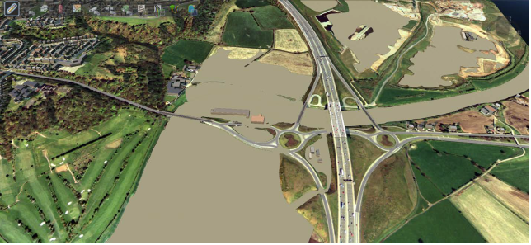

- The scheme will ensure that flood risk associated with surface water and sewer flooding is not increased as part of the proposed scheme. This means existing pockets of surface water flood risk may still remain after construction.

PROPOSALS (e.g. RATIONALE, DETAIL, FINANCIAL, PROCUREMENT)

- Initial Ground Investigation works started in March 2019 although actual construction is not expected to start until 2021. Construction is likely to take place in phases and take 3-5 years to complete. Any proposed defences will be built higher than existing and will likely be made up of flood walls, localised use of glass panels and embankments. By default the designs will be sympathetic to the character of local areas and through good design it is hoped to improve the look and feel of the riverside environment. The appearance of the defences has not been agreed.

- Any future defences will consider climate change and include environmental enhancements such as planting 3,000 additional trees and other environmental mitigation. There will also be a focus on growth, regeneration and natural flood risk management where possible.

- Climate change predictions are included in all of the modelling work, and the new guidance is currently being used to guide the scheme design. The scheme will be built to last into the future in line with climate change projections and the EA will make sure that the design of the defences can be topped up at some future date if needed.

- The scheme provides multiple opportunities in terms of making existing sites, homes and businesses more resilient to climate change. It also enhances the prospect of land becoming more viable in the future. Possibilities exist to enhance Preston and South Ribble as a result of the scheme.

- The cost of the scheme will be in the region of £45m. The scheme is part funded by European Regional Development Funding (ERDF) and this bid was supported by Lancashire LEP and Lancashire CC are the Accountable body for this funding. Funding comprises multiple sources with an additional £15.8m booster funding secured in September 2019.

- The EA have secured all the funding necessary for the scheme from European Region Development Funding and Flood Defence Grant Aid but not for the enhancements which may be required following the series of public engagement events. The scheme costs to date have been based on a simple design which may need to be changed.

- The Council has been asked to look to fund some of the additional enhancement for the scheme which will include a range of works to pathways, woodlands and open spaces along the River Ribble and Darwen. We are still in the planning stage of designing and costing these proposed environmental enhancements. Funding for the Environmental Enhancements work will be allocated from the Green Links capital programme which will be included in the Council’s Budget and Medium-Term Financial Strategy for approval in February 2020.

- During March 2018, the EA contacted residents in the areas affected to inform them that we are considering making improvements to the local flood protection in these areas. Several drop in sessions were undertaken to inform residents of the scheme including a mock-up of the potential defences. Residents during the consultation do want the flood defences improved in their area but were concerned about the size of the walls. Residents want enhancements which include glass panels, footpaths along the river and environmental improvements.

- Further engagement sessions are planned for October and November. Officers from South Ribble Borough Council will be attending these sessions to talk about our Green links programme and to find out what environmental enhancements our residents would like.

- The time table for the project is as follows:

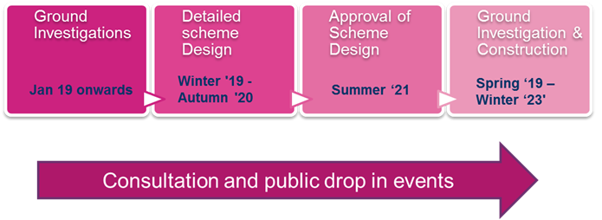

CONSULTATION CARRIED OUT AND OUTCOME OF CONSULTATION

- During March 2018, the EA contacted residents in the areas affected to inform them that we are considering making improvements to the local flood protection in these areas. Several drop in sessions were undertaken to inform residents of the scheme including a mock-up of the potential defences.

- South Ribble Borough Council staff and members attended these sessions with information and display boards about our Green Links Programme. Further engagement sessions have been undertaken in October and will be undertaken in November. These sessions have been well attended by members of the public.

ALTERNATIVE OPTIONS CONSIDERED AND REJECTED

- An alternative option would be to do nothing or reduce the scheme. The flood risk modelling has shown that the resident and businesses in that area are at significant risk of flooding and that the current flood defences are coming to the end of their design life and are required to be either repaired, raised or replaced.

Financial implications

- The proposed scheme is likely to cost in the region of £45m. The project partners have secured all the funding necessary for the scheme from European Region Development funding and flood defence grant aid.

- The scheme costs to date have been based on a simple design which may need to be changed.

- Enhancements may be required following the series of public engagement events and these there still need to be designed and costed.

LEGAL IMPLICATIONS

- This report is essentially for noting. At this juncture therefore there are no direct legal implications arising. If at a later date we agree to carry out some improvements along the rivers Ribble and Darwen then careful consideration of legal implications will have to be carried out at that stage.
AIR QUALITY IMPLICATIONS

- During the construction phase of the works there will be impact on air quality, but the EA will be working closely with the construction company to minimise these impacts. Once the construction is completed the scheme with have a positive impact by the planting of trees and enhancing footpaths and cycleway to encourage people get out of their cars.

Human Resources and Organisational Development implications

- None

ICT/technology implications

- None.

Property and Asset Management implications

- Officers are working closely with the EA to understand any implications this project will have on our Council assets such as Penwortham Holme. The scheme has been designed to ensure that flood risk associated with surface water and sewer flooding is not increased as part of the proposed scheme. This means existing pockets of surface water flood risk may still remain after construction which may affect our assets.

RISK MANAGEMENT

- As discussed in the report funding has been secured and a programme has been agreed that will substantially reduce the flood risk to 2000 residential and 600 commercial properties in South Ribble and Preston, but the key risk to this project is the lack of public engagement. As discussed in the report residents want the scheme but during the first engagement events they were concerned with the look of the scheme. Officers are working with the EA to run further engagement event and to work together on enhancement to the environment of the waterfront.

EQUALITY AND DIVERSITY IMPACT

- None

RELEVANT DIRECTORS RECOMMENDATIONS

- Cabinet are asked to note the Preston and South Ribble Flood Management Scheme proposals and will provide on-going support feedback and suggestions that can help shape/inform the ongoing process.

- Cabinet agrees to work with the Environment Agency to deliver improvements as part of the Green Links programme along the River Ribble and Darwen which will include a range of works to pathways, woodlands and open spaces.

COMMENTS OF THE STATUTORY FINANCE OFFICER

- Funding for environmental enhancements work will be allocated from the Green Links capital programme. The schemes will be included in the council’s budget and medium-term financial strategy for approval in February 2020.

COMMENTS OF THE MONITORING OFFICER

- Clearly it is right and proper that this council should seek to work with partner organisations to reduce the risk of flooding for its residents. The Local Government Act 1972 and the Localism Act 2011 grant wide ranging statutory powers on which we can rely. However, at this stage there are no direct legal implications arising from the report.

BACKGROUND DOCUMENTS

There are no background papers to this report

APPENDICES (or There are no appendices to this report)

Appendix A Diagram of proposed defences.

LT Member’s Name: Jennifer Mullin
Job Title: Director of Neighbourhoods and Development

Report Author: | Telephone: | Date:
Jennifer Mullin Director of Neighbourhoods and Development | 01772 625329 | 18/10/19

